|  |  |
| --- | --- |
| **Course Code: CSL601** | **Course Name: SE LAB** |
| **Class : TE-CO** | **Batch : 3** |
| **Roll no : 18CO63** | **Name : SHAIKH TAUSEEF MUSHTAQUE ALI** |

**Experiment: 06**

**Aim: Draw DFD (upto 2 levels) and prepare Data Dictionary for the project.**

**Output:**

**DFD LEVEL 0:**

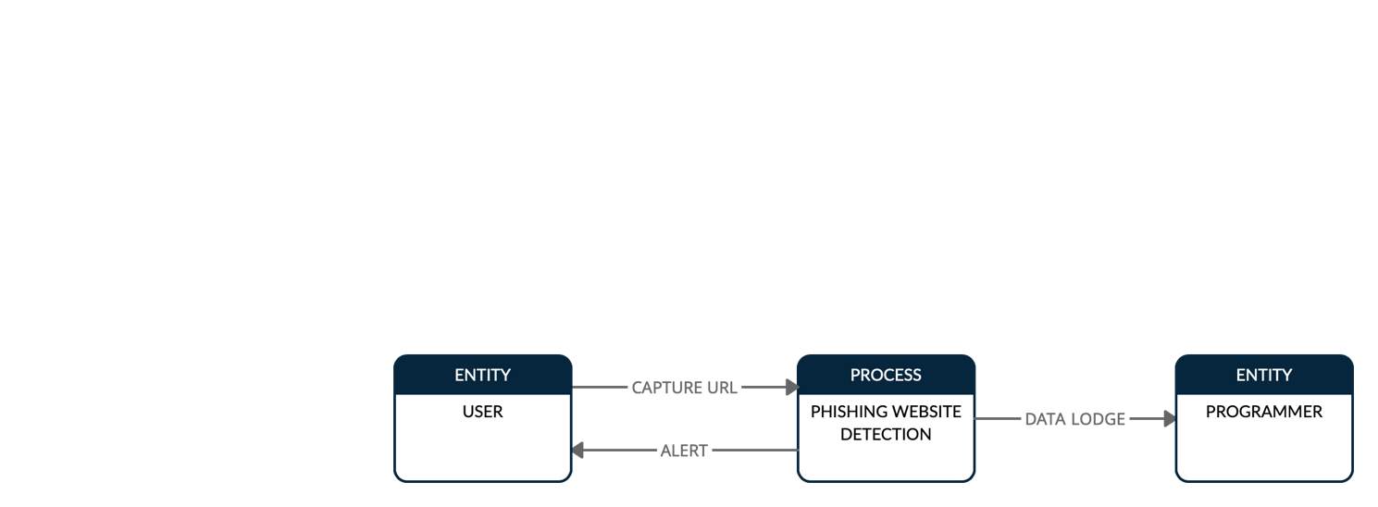

**DFD LEVEL 1:**

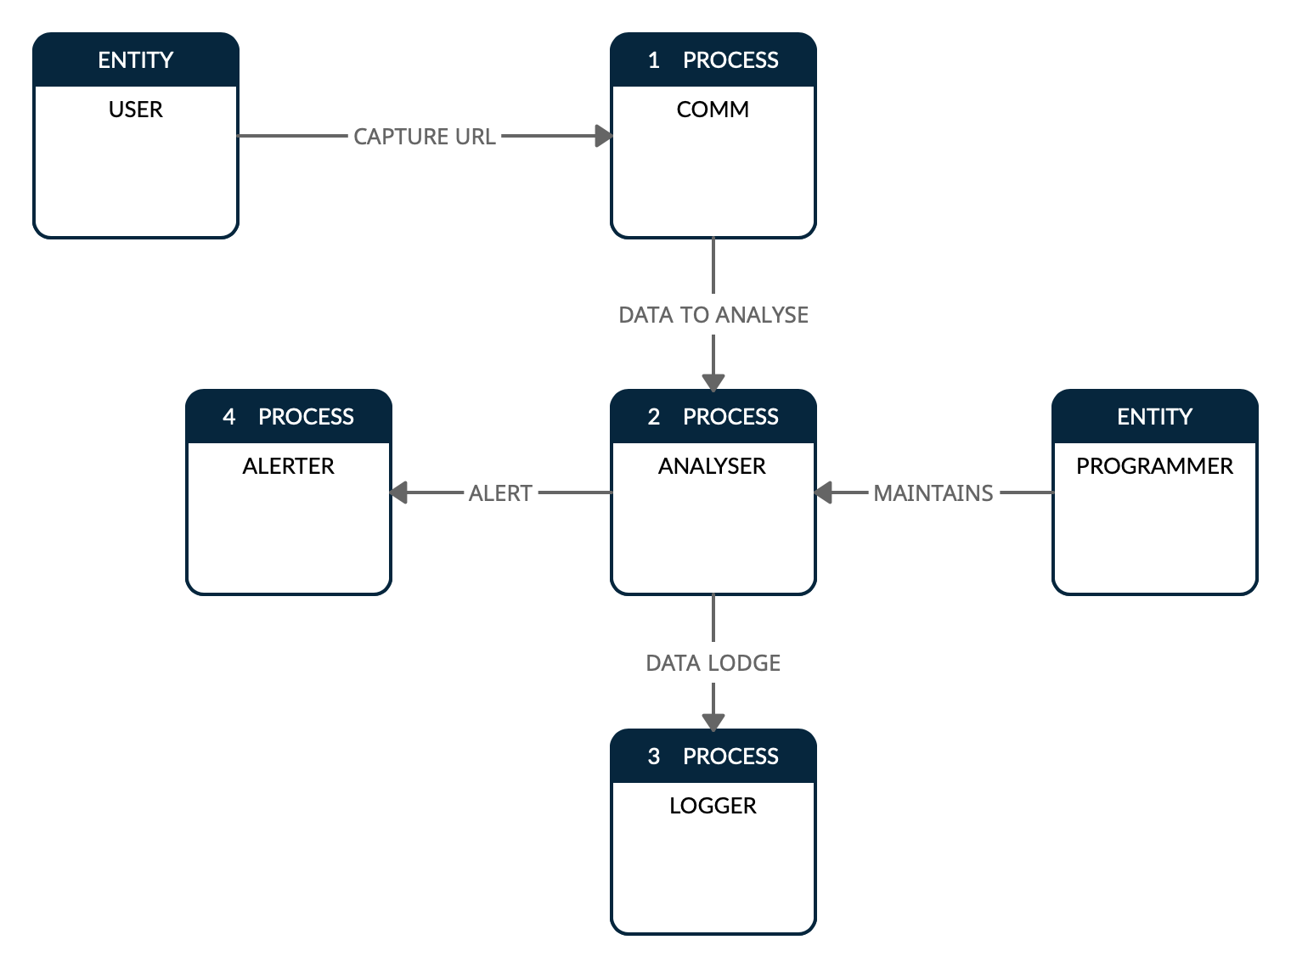

**DFD LEVEL 2:**

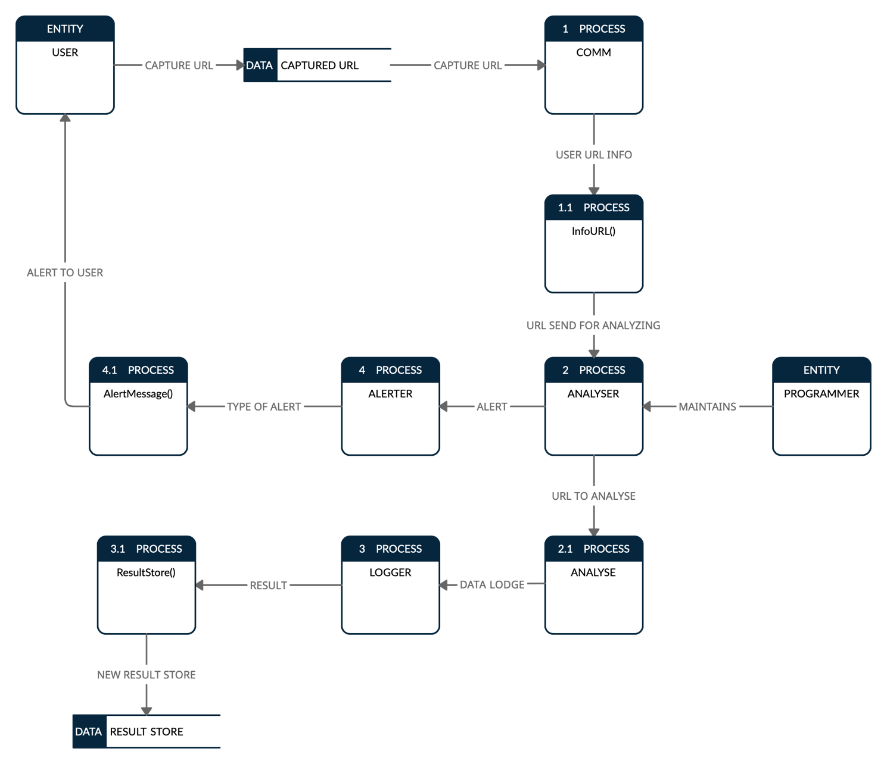

**Reference:**

[**https://www.lucidchart.com/pages/data-flow-diagram**](https://www.lucidchart.com/pages/data-flow-diagram)

[**https://www.visual-paradigm.com/guide/data-flow-diagram/what-is-data-flow-diagram/**](https://www.visual-paradigm.com/guide/data-flow-diagram/what-is-data-flow-diagram/)

[**https://www.draw.io/**](https://www.draw.io/)

[**https://creately.com/**](https://creately.com/)

**Conclusion:**

|  |
| --- |
| With the Help of this Experiment, we are able to construct a DFD with understanding the data flow of our |
| Specific topic. |